LAB Logbook
Link
Lab 1
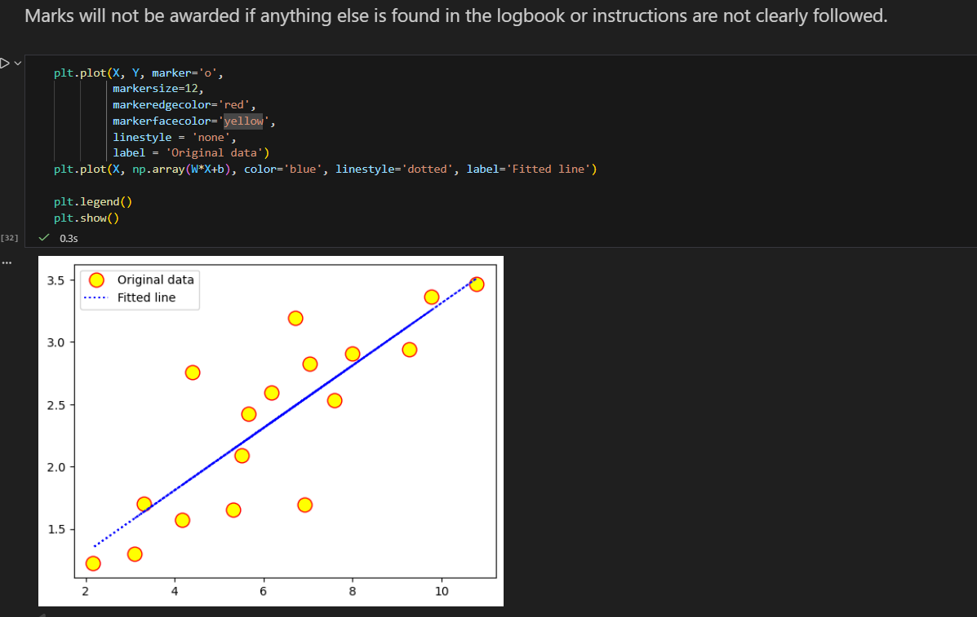

Lab 2

LAB 2
Task 1
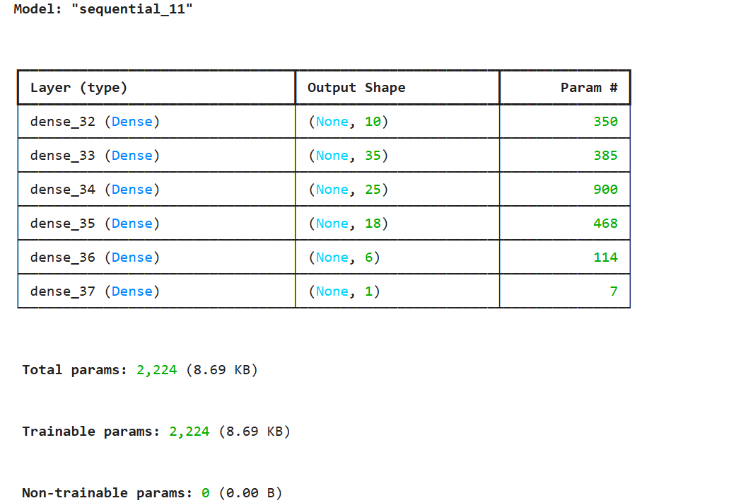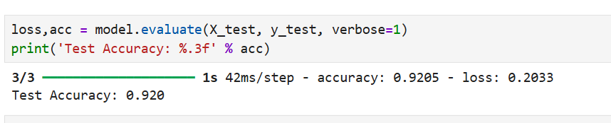
Task 2
Output result: 0.9833151483

Lab 3
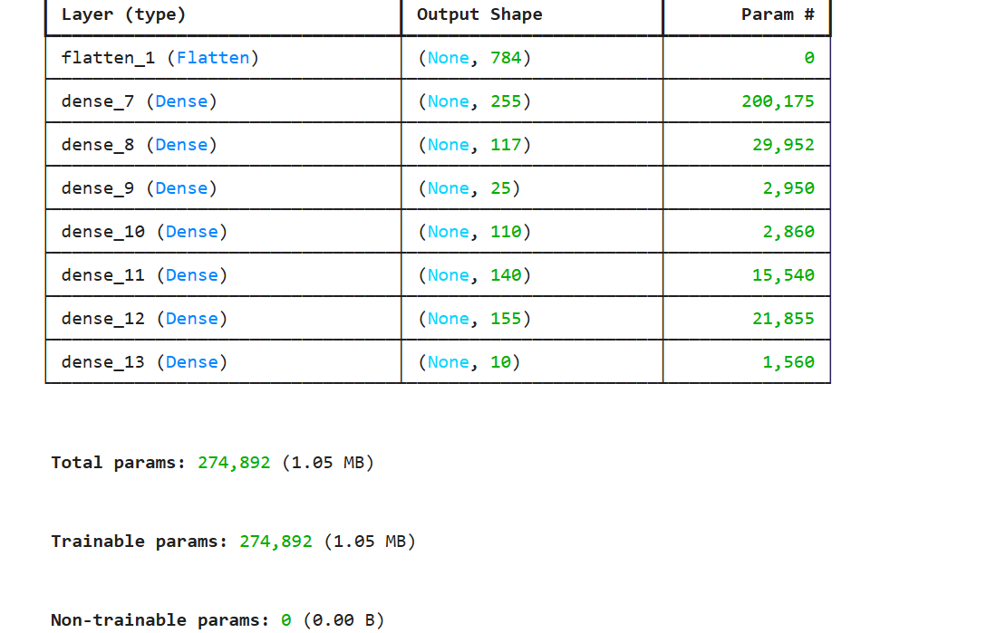

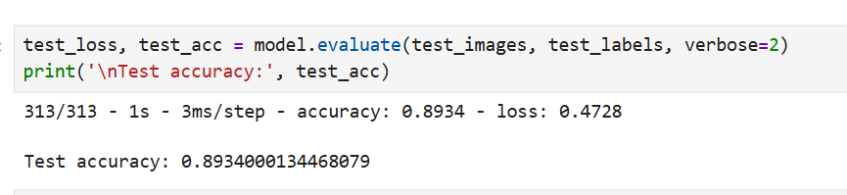

LAB 4
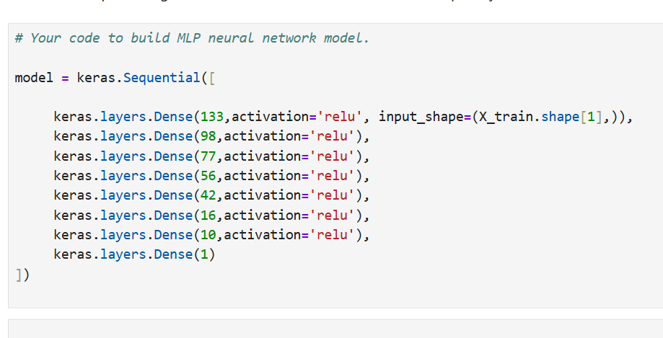
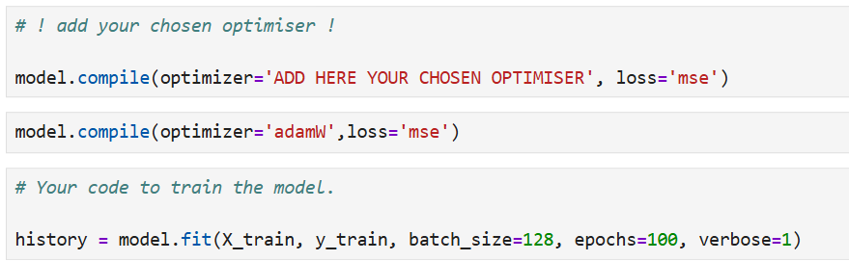
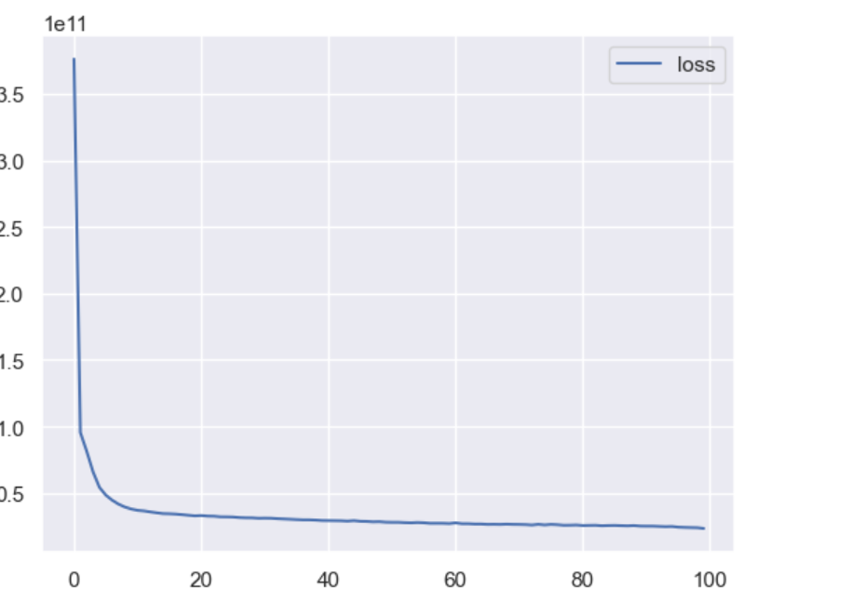

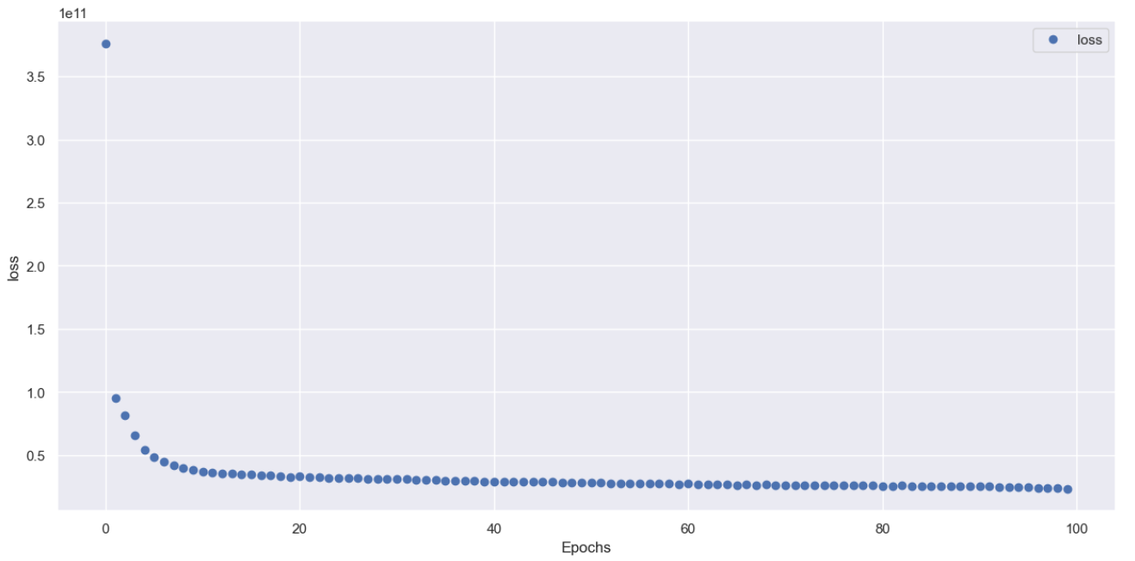

Lab 5

Lab 6

Lab 7

Lab 8

Lab 9

Lab 10

Lab 11

Lab 12

